Academic Profile
Name : Purnachandra Patra
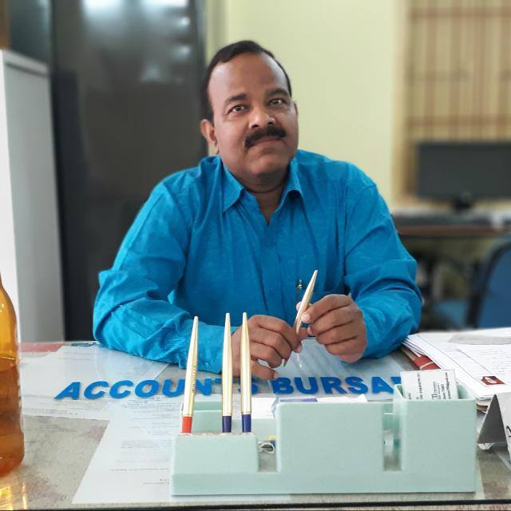
Designation: Asst. Professor
Department: Economics
Mob : +91 977279898
Email: gmail.com
Educational Qualification: MA
Specialization:
Teaching Experience:

Publications:
- Title of the Paper: Value
Journal:
ISSN
Vol- Issue
- Title of the Paper:
Journal:
ISSN
Vol- Issue

Seminars/Workshops/
- Type: National
Title of Conference:
Title of the Paper Presented-
Date From:
Organized By:
- Type: National
Title of Conference:
Title of the Paper Presented-
Date From:
Organized By:
- Type: National
Title of Conference:
Title of the Paper Presented-
Date From:
Organized By:

Administrative Assignments:
- Coordinator RUSA
- Member
- Member
- Member-
- Member-
Extra Institutional Affiliation:
Extraordinary Feats:
>>>>>>>0<<<<<<<

